**“LITERATURE FOR SCHIFF BASES”**

AProjectSubmittedtoUniversityofMumbai

M.Sc.Part(II)SEM-IV

In

ORGANIC CHEMISTRY

SUBMITTED BY **SIMPLE.V. JHA**

**Seat No: 1123179**

UNDER THE GUIDANCE OF

**Dr. SHEETAL PAWAR**

Department Of Chemistry

VivaCollege, Virar (W)

YEAR 2024-2025

**LATE SHRI VISHNU WAMAN THAKUR CHARITABLE**

**TRUST’S BHASKAR WAMAN THAKUR COLLEGE OF**

**SCIENCE, YASHWANT KESHAV PATIL COLLEGE OF**

**COMMERCE, VIDHYA DAYANAND PATIL COLLEGE**

**OF ARTS, VIRAR WEST**

**CERTIFICATE**

This is to certify that **SIMPLE VINOD JHA of** M.Sc. Part (II) SEM-III 2024-2025, Seat number - **1123179** has successfully completed the research project entitled **“LITERATURE FOR SCHIFF BASES”** in the subject of organic chemistry under the guidance of **Prof. Dr. SHEETAL PAWAR.**

**Professor-in-charge** **Head of Department** **Examiner**

**College Stamp**

**DECLARATION**

I, **SIMPLE VINOD JHA**, student of M.Sc. Part (II) SEM-IV Organic Chemistry, Viva College, Virar west, hereby declare that, I have completed project on **“LITERATURE FOR SCHIFF BASES”** in academic year 2024-2025.

Theinformationsubmittedistruetothebest of my knowledge.

**SIGNATORY**

**( SIMPLE VINOD JHA )**

**Date :**

**Place :**

**ACKNOWLEGMENT**

I would like to express my humble and gratitude to the Chemistry Department of **LATE SHRI. VISHNU WAMAN THAKUR** **CHRITABLE TRUST’S BHASHAR WAMAN THAKUR COLLEGE** **OF** **SCIENECE, VIRAR** **(W), PALGHAR,** for giving me the opportunity for carrying out the project entitled **“LITERATURE FOR** **SCHIFF BASES”** for the final year as per the curriculum of degree course of Masters in Chemistry.

I am also thankful to **Prof. Arti Dubey, Head of Chemistry**

**Department,** for his sincere and wholehearted co-operation and

guidance. I would like to express my deep and sincere gratitude to my project guide **Prof. Dr. Sheetal Pawar** for the valuable guidance and her whole-hearted support with constructive criticism and words of encouragement in all aspects of my work.

I would like to thank all the staff members and lab assistants of

Chemistry Department.

**INTRODUCTION**

**SCIFFS BASES**

Schiff bases are synthesized typically by the condensation of primary amine and aldehyde/ketone. Schiff bases are oriented from amines and aromatic aldehyde have a variety of application in many fields such as Analytical Inorganic Biological. Schiff bases are often colored compounds. They can act as ligands, forming metal complexes schiff bases are mainly bidentate, tridentate, tetradentate or polydentate ligands capable of forming very stable complexes with their transition metals.   
 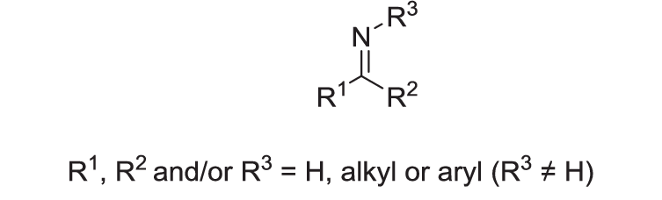

**Metal** **Complex:**

Metal complexes play a vital role in various fields of chemistry, including coordination chemistry, inorganic chemistry, and materials science. These complexes are formed when metal ions coordinate with one or more ligands, resulting in unique structures and properties that can be harnessed for diverse applications. The study of metal complexes provides insights into fundamental chemical principles and offers a platform for designing novel materials with tailored functionalities.

Metal complexes exhibit a wide range of fascinating properties, such as redox activity, catalytic activity, magnetic properties, and luminescence. These properties arise from the electronic structures and geometries of the metal-ligand coordination bonds. By manipulating the choice of ligands and metal ions, it is possible to tune the properties of metal complexes and explore their potential applications in various fields.

1. **Copper** Cophper has three stable oxidation state . it form peroxo and superoxo complexes wit nitrogen donar ligands such as polydentate aliphatic amine ligands and heterocyclic nitrogen donar ligands and oxygen donar ligands such as phenol-based ligands.
2. **Cobalt** The most significant cobalt minerals are smaltite and cobaltite. There are many known dinuclear carboxylate complexes that are stabilized with nitrogen ligands.

**Ligands:**

Ligands are molecules or ions that can donate one or more pairs of electrons to a central metal ion or atom to form a coordination complex. In coordination chemistry, the central metal ion or atom is typically a transition metal, although other metals can also form coordination complexes.

Metal complexes with Schiff base ligands have garnered significant attention in the field of coordination chemistry due to their intriguing structures and versatile properties. Schiff bases are characterized by the presence of an imine (-C=N-) linkage, which provides a strong coordinating site for metal ions.

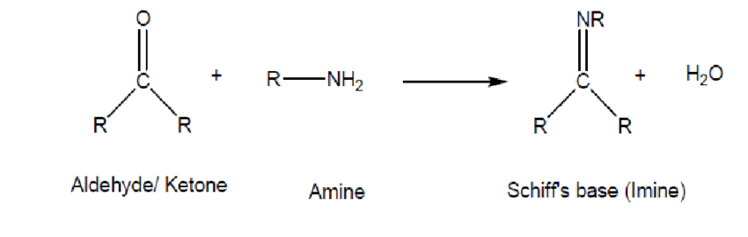

**Characterization using IR Spectroscopy**

Infrared (IR) spectroscopy: IR spectroscopy can be used to identify the functional groups present in the Schiff base compound. The characteristic absorption bands of C=N and C-O in Schiff bases can be observed in the IR spectrum **Natural Occurrence** Salicylaldehyde is a characteristic aroma component of buckwheat. It is also one of the components of castoreum. salicylaldehyde occurs in larval cautions secretion of several leaf beetle species that belong the subtribe Chrysomelina.

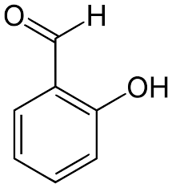

***SALICYLALDEHYDE***

**REACTION**

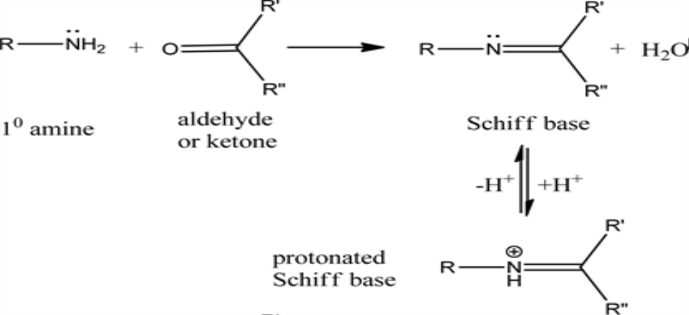

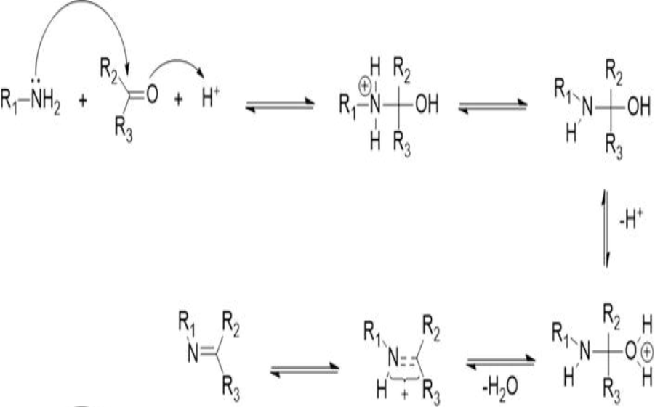**MECHANISM**

**SYNTHESIS OF SCHIFF BASE REAGENTS**

R.A solution of o-phenylenediamine (0.1mmol) in methanolis added to a mixture of Acetyl acetone (0.1mmol) and salicylaldehyde (0.1mmol) in 20 ml methanol and water . the mixture is refluxed for about 30 minutes . the mixture is cooled in ice. The resulting precipitate is then filtered , washed with methanol and dried.

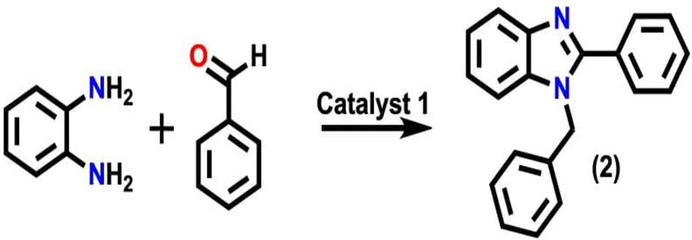

**IPLE OF INFRARED SPECTROSCOPY:**

• The IR spectroscopy theory utilizes the concept that molecules tend to absorb specific frequencies of light that are characteristic of the corresponding structure of the molecules.

• The energies are reliant on the shape of the molecular surfaces, the associated vibronic coupling, and the mass corresponding to the atoms.

**Application**

Schiff bases oriented from an amino and carbonyl compounds are an important class of ligands that coordinate to metal ions through azomethine nitrogen and have been studied extensively. In azomethine derivative the C=N linkage is essential for biological activity.

1. **ANTIMICROBIAL**: and gram negative bacteria , were potent than , or similar with commercial antibiotics ( Kanamycin and Penicillin) . Schiff base synthesized from indoline-2,3-dione and 2-aminobenzoic acid and its Tin complex showed antibacterial activity against Staphylococcus aureus. The Zn complex showed a huge amount of Bactericidal activities against the Gram positive
2. **ANTITUMOR**: Metal complexs of Sciff base synthesized from 2-thiophenecaboxaldehyde and 2-aminobenzoic acid is used as antitumor agent in synthetic and semi synthetic compounds . e.g. Hodnett et al. and Hickmann .

.

1. **ANTIVIRAL**: Schiff bases show high antiviral activity. Silver metal complexes in oxidation state one exibit greater inhibition against Cucumber mosaic virus.
2. **SYNTHETIC ACTION ON INSECTICIDES**: Schiff base synthesized from sulfane thiadizole show toxicities and salicylaldehydeorthiophene-2-aldehyde and their metal organic complexes show toxicities against insects.

1. **CATALYST** Co (2), Fe (3), Ru(3) complexes of Schiff bases derived from hydroxybenzaldehyde are used in oxidation of cyclohexane into cyclohexanol abd cyclohexanone in presence of hydrogen peroxide.
2. **DYE** **INDUSTRY**  The Technique employs a wide range of schiffs bases and complesxes many of which have been synthesized as mordants. The textile industry utilizes these dye stuff to colour a variety of materials.
3. **FOOD** **INDUSTRY** It is used to produce natural novel and active materials for food packaging applications. Because of their antibacterial action, chitosan-derived Schiff base films boost safety of foods , also lengthen their shelf life and

## **ANALYTICAL** **APPLICATION** Schiff bases have been used as probes or reagents by researcher . These are used as primary amines, carbonyl compound, and functional group.

## **BIO SENSING APPLICATION** Schiffbase compounds have been used as Biosensors for H2O2 , glucose, and oncomarker CA-125 . Evolution of the sensitivity and specificity of the gold Schiff base complex – doped sol gel nano optical sensor for the detection of CA-125 in ovarian cancer patient .

**CONCLUSION**

Schiff bases are compounds formed by the condensation of an aldehyde or ketone with a primary amine, and they are known for their diverse chemical and biological activities. Schiff bases and their metal complexes formed are essential component of coordination and bioinorganic chemistry. The food industry the agrochemical industry, the dye industry , analytical chemistry, catalysis , energy storage , environmental fields , chemo-sensing, and biomedical sector are some of the domains in which these have been used.

Research into its application in other fields of interest , such as catalysis , metal ion sensing, and cell imaging, makes its study relevant nd worthy of being pursued.

Characterization techniques such as infrared (IR) spectroscopy provide crucial information about the structure and properties of the synthesized compound.

**Reference**

1. Schiff H. Mittheilungen aus dem universitats-laboratorium in Pisa . Justus Liebigs Annalen der Chemie. 1864.

2. ‘Studies on multimetallic complexes with salicylamidine Schiff base ligands’ Roy Sourav , 2018. .

3. Singh A , Gogoi Barman P, Guha AK , Novel thioether Schiff base.

4. ‘Study of metal complexes with Schiff bases’ Shirodkar sanjay G , 1998 .

5. ‘Novel schiff bases synthesis characterization and pharmacological studies’ shiv Naga Anjanyega Prasad , 2017